GIT install instructions – install version 1.8.1.2 using this link:

1. Install using this link and make sure to check Git Bash and Git GUI as shown below: <http://code.google.com/p/msysgit/downloads/detail?name=Git-1.8.1.2-preview20130201.exe&can=2&q=full+installer+official+git>

Make sure to check Git Bash Here and Git GUI Here as shown below:

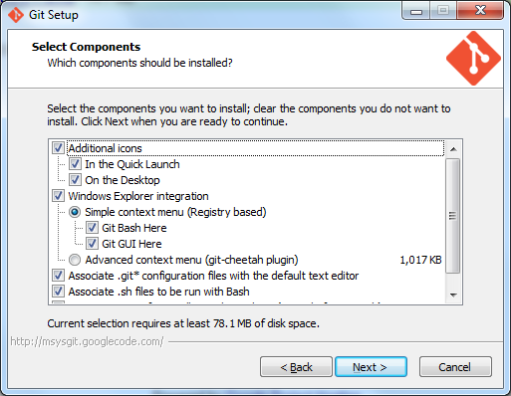

1. Install again using this link and select the ‘Advanced context menu (git-cheetah plugin) radio button this time: <http://code.google.com/p/msysgit/downloads/detail?name=Git-1.8.1.2-preview20130201.exe&can=2&q=full+installer+official+git>